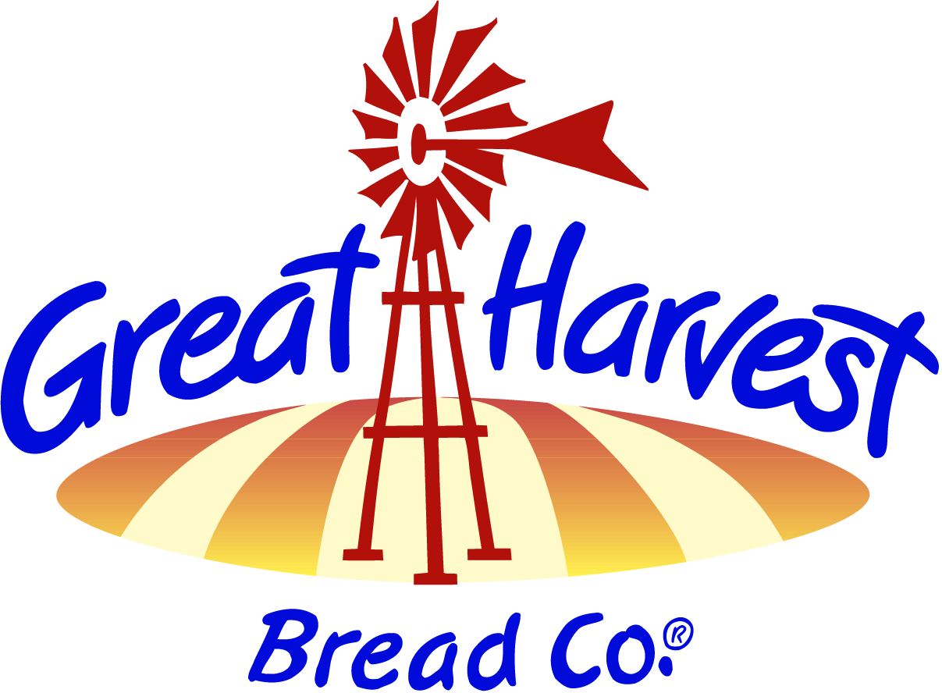

Production Manager Job Description

- Provide supervision of production employees. Keep Manager/Owner up to date regarding issues of importance. In the absence of Manager/Owner, substitute for the Bakery Manager/Owner for Burke & Lorton.
- Demonstrated passion for Customer Service with the ability to train and motivate and mentor others to deliver exceptional product quality and customer service.
- Proven ability to build sales including community events and marketing, achieve financial goals including gross margin and labor costs. Able to use technical and financial information to identify opportunities and solve problems.
- Contributes in menu creation, variety and coordinates quantity of products to be produced, according to orders and sales projections of all products.
- Well developed product knowledge and the ability to prepare a variety of breads and sweets from scratch with knowledge of bakery production equipment use, cleanliness and maintenance & process controls
- Sets, communicates and keeps Team Members accountable for high standards of performance. Provides formal and informal feedback to Team members in order to recognize good performance and strengthen performance in opportunity areas.
- Manages inventory, delivery and ordering to ensure selection, freshness, and availability of product to drive sales. Follows procedures for effective inventory control and end of the month counting by conducting or supervising.
- Decision Making, delegating, developing others, initiating action, managing change, planning and organizing, results oriented, sets high standards.
- Work with Bakery Manager/Owner on development of new items and/or enhancement of existing products.
- Other related duties as assigned.

